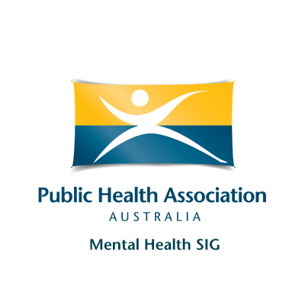

Mental Health Special Interest Group Award
Mental Health Champion and Emerging Voice in Mental Health 2026

The Mental Health (MH) SIG will confer three Mental Health Awards across two categories: one Mental Health Champion Award and two Emerging Leader Awards.
The Award comprises a framed certificate to be presented at the Preventive Mental Health Conference 2026 in Parramatta, Sydney.
ELIGIBILITY
General eligibility (applies to both categories)
- The nominee must be a member of PHAA, preferably a member of the Mental Health (MH) SIG.
- The nominee must be an Australian resident.
- The nominee’s contributions may be in any area of mental health, including research, practice, policy, community engagement, advocacy, service development, or capacity strengthening.
- Nominees are eligible to receive an “Mental Health Champion/ Emerging Voice in Mental Health” award once only in their lifetime.
Category 1: Mental Health Champion Award (1 award)
- Intended for an individual who demonstrates exceptional leadership and sustained contribution to mental health in Australia or internationally through an Australia-led initiative.
- Nominees may be within the first 10 years of their career (full-time equivalent, allowing for career interruptions) or may have a career of more than 10 years but have completed a PhD within the last 5 years.
Category 2: Emerging Leader Awards (2 awards)
- Intended for individuals who demonstrate clear emerging leadership and strong early contributions and momentum in mental health in Australia or internationally through an Australia-led initiative.
- Nominees must be within the first 10 years of their career (full-time equivalent, allowing for career interruptions) or have completed a PhD within the last 5 years.
Note on Category Placement
- Applicants may indicate their preferred category (Champion or Emerging Leader). However, the Award Committee may place nominations in the most appropriate category based on the evidence provided and the overall pool of applicants.

APPLICATION GUIDELINES
The nominee needs to provide:
- A completed nomination form (see below)
- A brief CV of the nominee (not more than 4 pages)
Submission Deadline
- Nominations must be submitted by COB 6 March 2026. Late applications will not be accepted.
How to submit
- Nominations should be forwarded to Dr. Manika Saha (Chair, Award Committee, Mental Health Award 2026, MH SIG, PHAA) via MHSIG@phaa.net.au, with a copy to manika.saha@monash.edu
SELECTION PROCESS
- The Mental Health SIG Committee awards reviewers will select the recipient of the award based on their:
- Voluntary and/or paid work contributions to mental health above and beyond the expectations of their regular employment.
- Leadership and contributions to mental health in Australia/ internationally (through Australian led initiative).
- Publications and/or other scholarships related to mental health.
- Other relevant professional activities, excellence, and endeavour related to mental health.
- The Committee may request additional information/ documentation from the nominee or nominators if deemed necessary.
- The Committee may choose not to present the award, depending upon the merit of the nominees.
- The panel will determine the final recipients, including which nominee is awarded the Champion Award and which nominees receive the Emerging Leader Awards, based on the strength of the applications and the panel’s overall judgment.

For more information contact MH SIG, MHSIG@phaa.net.au/ manika.saha@monash.edu

​​

NOMINATION FORM
Mental Health Special Interest Group Award
Mental Health Champion and Emerging Voice in Mental Health 2026
NOMINEE DETAILS
Name
Current Affiliation(s)
Phone |  |  | Email
PHAA Member  MH SIG Member | □ YES Number of years joined? ..................................... □ NO  □ YES Number of years joined? ..................................... □ NO
Australian resident | □ YES □ NO
Award Category | □ Mental Health Champion □ Emerging Voice in Mental Health 2026
Academic qualifications
(most recent first)
Years working in mental health
Contribution to PHAA (and MH SIG) (200 words)
Contributions in mental health (500 words)
Authored publications (Top 5 publications with a Google Scholar/ ResearchGate link)
Other relevant contributions

Name |  | Signature | [Electronic signature acceptable]

